Wireframe:
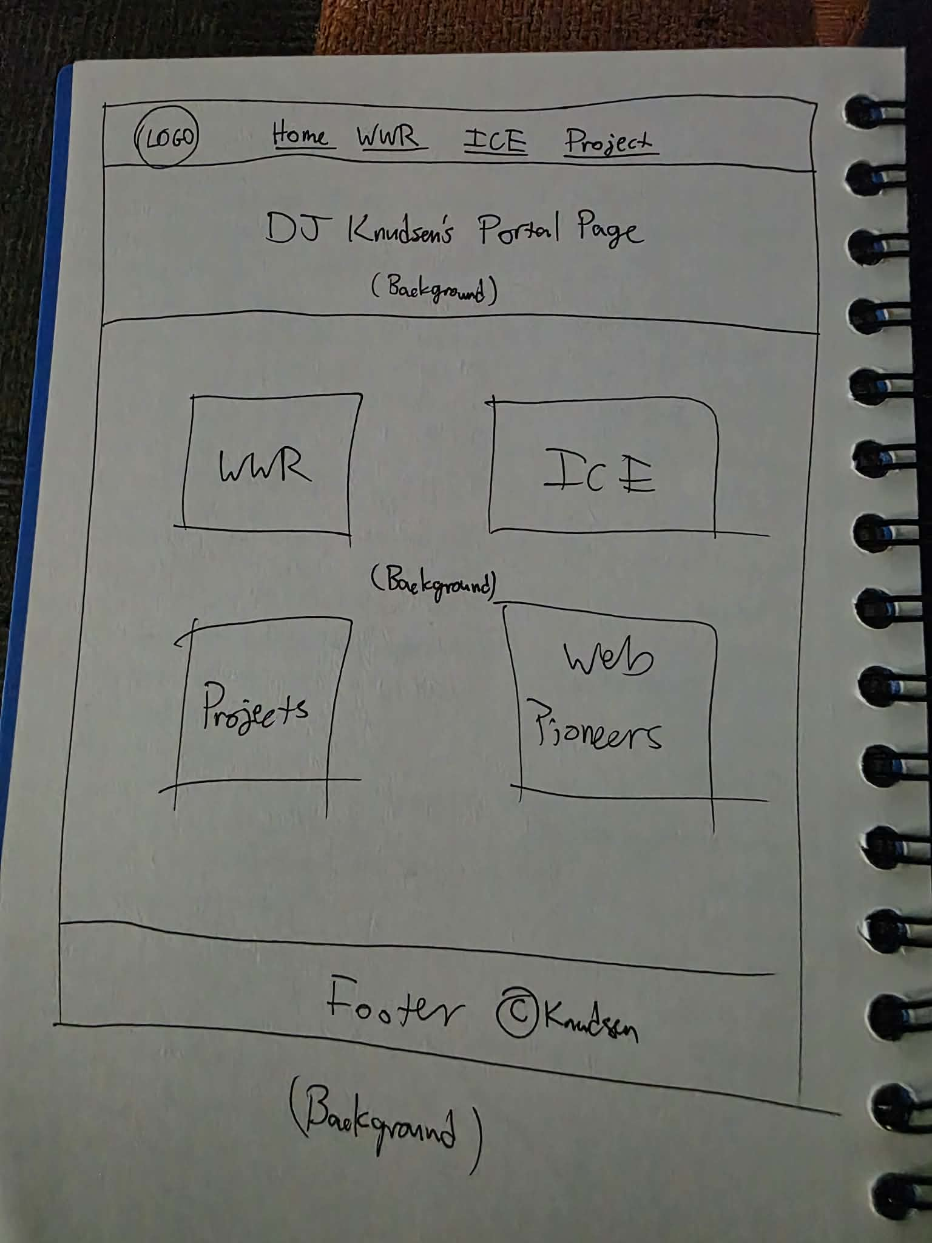
Logo:
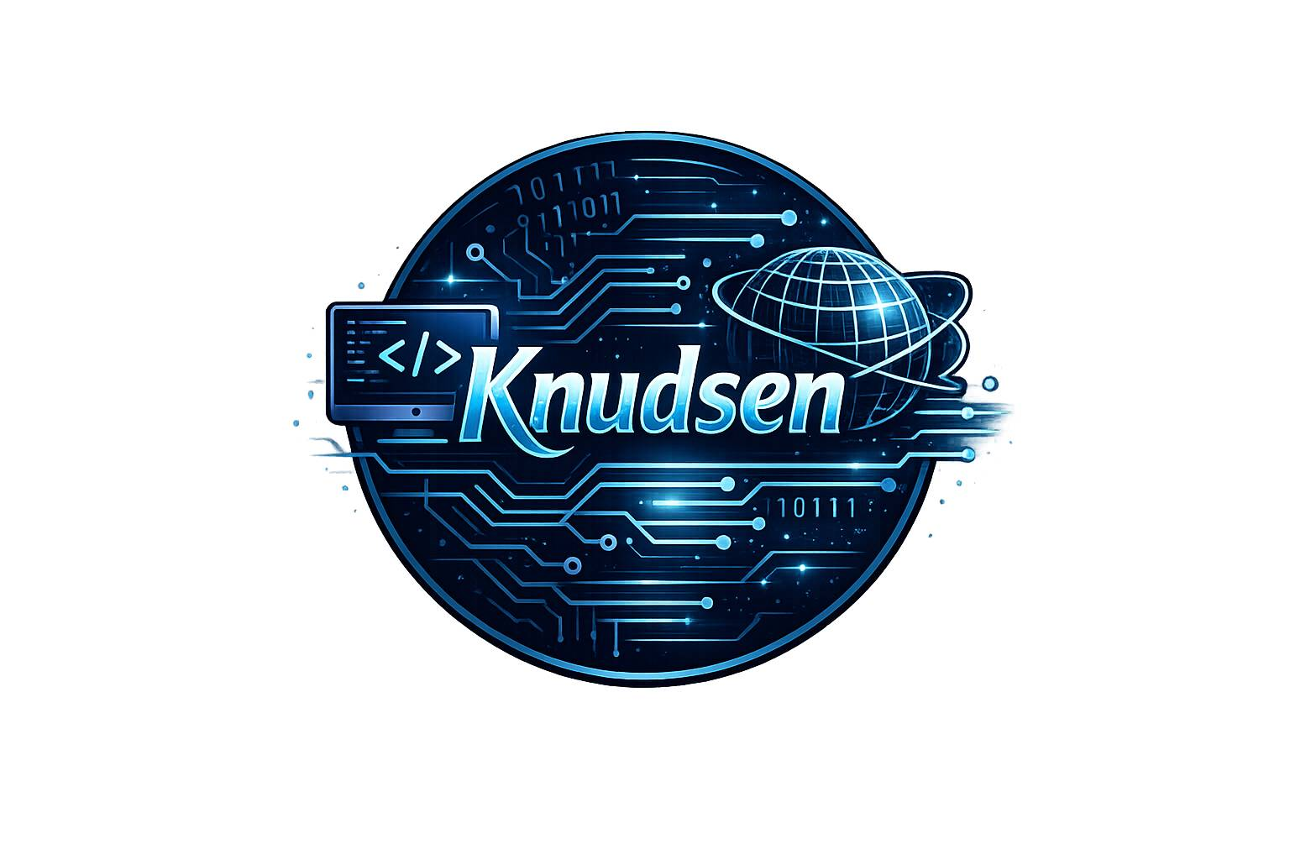
Background:

Color scheme:

6EAFCD FEFEFE 82DDF4 BBE9F4 000D27

Fonts:
Google Fonts:
Special Elite
Share Tech Mono
Cinzel Semibold
IM Fell English

